Coursework 1 DBMS

**Part I: Entity-Relationship Diagram**

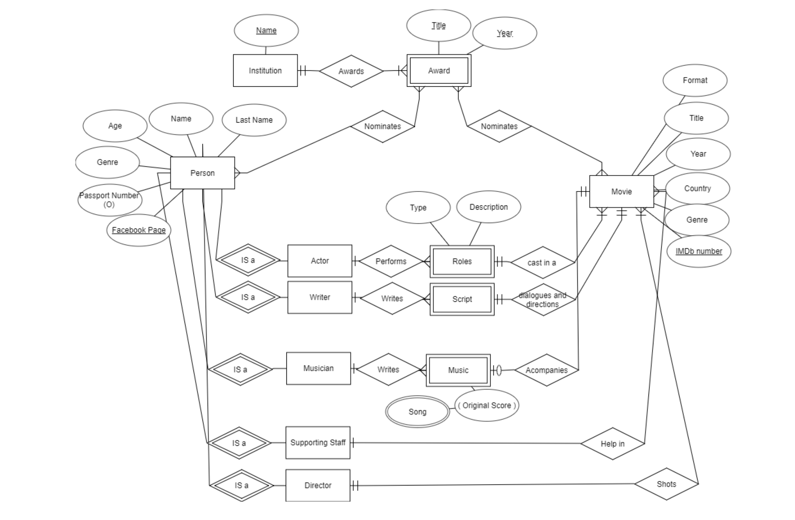

**STEPS**

1. **Identify entity types / Primary Keys**

* Institution. Its name is its Primary Key and it is a Foreign Key for Award.
* Award. It is a weak Entity. Only can be identified if linked to an Institution. For instance, Best Movie Award in 2013 can only be identified if the Institution is as well declared.
* Movie. Not easy to find a Primary Key. I have chosen IMDb (very well known database in the industry that identifies uniquely each movie).
* Person. As mention in the text they are identified by their Facebook page. Note that in real world this can be tricky since not everybody may have one. Other id could be the Passport number (almost everybody has one despite not being mandatory)
* Actor: IS A entity (speciality of a Person).

I have added other entities (IS A, specialties with special properties derived not from Person Entity) considered in the question (they all inherit the attributes and primary keys of Person):

* Writer.
* Musician.
* Supporting Staff (I have grouped here all supporting roles needed for a movie that can be nominated to an award: production designers, Hairstylers, Costume Designers,…)
* Director.

Finally, I have added some weak entities (linked to movies) that may be part of an award nomination (given to the person who created them.

* Roles. Weak entity, only can be determined through its link to a movie. Can be Leading or Supporting.
* Script. Weak entity, Linked to a movie.
* Music. Weak entity. Linked to a movie.

1. **Identify relationships (ISA / ID).**

Actor, Director, Supporting Role, Writer, Musician are ISA entities derived for Person Entity (Parent).

1. **Identify relationships – multiplicity**

* Institution awards an Award. Many to Many relationship. One Institution (Oscars) can give many awards. An Award (Best Actress in a Leading Role) can be given by several institutions (for instance Oscars and BAFTA).
* Award is nominated to a Person. Many to Many relationship. A person can be nominated with Many Awards (Best Actor, Best Director, Best Actor in a secondary role,…) and an Award can nominate several person (before they are awarded), but even the final award can be given to more than one person (for instance there are more than one Production Designer in a movie).
* Award is nominated to Movie. Again a movie can be nominated with several awards (Best movie, Best foreign movie,…) and an award can nominate several movies (until one is awarded).
* Person is an actor. Inherits their main attributes.
* Actor performs a Role. One to many relationship: one actor can perform several roles in a movie (although it is not usual) but a role can only be perform by one actor (I consider that a character performed by 2 different actors are two different actors).
* Role casts in a Movie. Role is a weak entity (only can be identified in the context of a movie). It is a mandatory (a role has to perform in a movie) and one to many relationship: a movie may have many roles but a role is performed in a specific movie.

1. **Participation constraints.**

* There are several mandatory relationships:
  + Between Institution and Award. Every Award should be awarded / nominated by a Institution. Award is a weak entity that only can be identified when referred to an Institution.
  + An Actor has to perform a role, the nomination is to an actor playing an specific role in a movie.
  + A role has to be linked to a movie. As mentioned before, the role has to be performed in a movie.

1. **Draw ERD with entity types /relationships.** See first Image. I have used IDE1FX notation.
2. **Identify attributes entity – relationships.**

* Institution. Name.
* Award. Name, Year.
* Movie. Title, Year, Country /Nationality, IMDb, Genre, Format (for instance Film, Animation, Documentary,…).
* Person. Name, Last Name, Age, Genre, Passport N (Optional), Facebook page Id
* Actor: IS A entity (speciality of a Person).
* Role: Description and Type (Leading or supporting role).

1. **Primary key for entity type.**

* Institution: Name.
* Award: Weak Entity. Hast to be referred to an Institution. To form the Key we have to add the Name of the Award and the Year. For example: BAFTA Best Actor in a Leading Role in 2019
* Actor: Facebook Page (but note that in real life it would not be valid). IS A Entities derived from Actor inherit their primary key.
* Movie: IMDb number is probably the best unique identifier (it can be equivalent to ISBN in books but IMDb is a private company owned by Amazon).
* Roles / Script / Music: only can be uniquely identified by their link to a movie and an Actor/Writer/Musician.

1. **Add attributes and primary keys to the ERD**. Already done in the first image.